Farmer Support Platform

Overall Framework

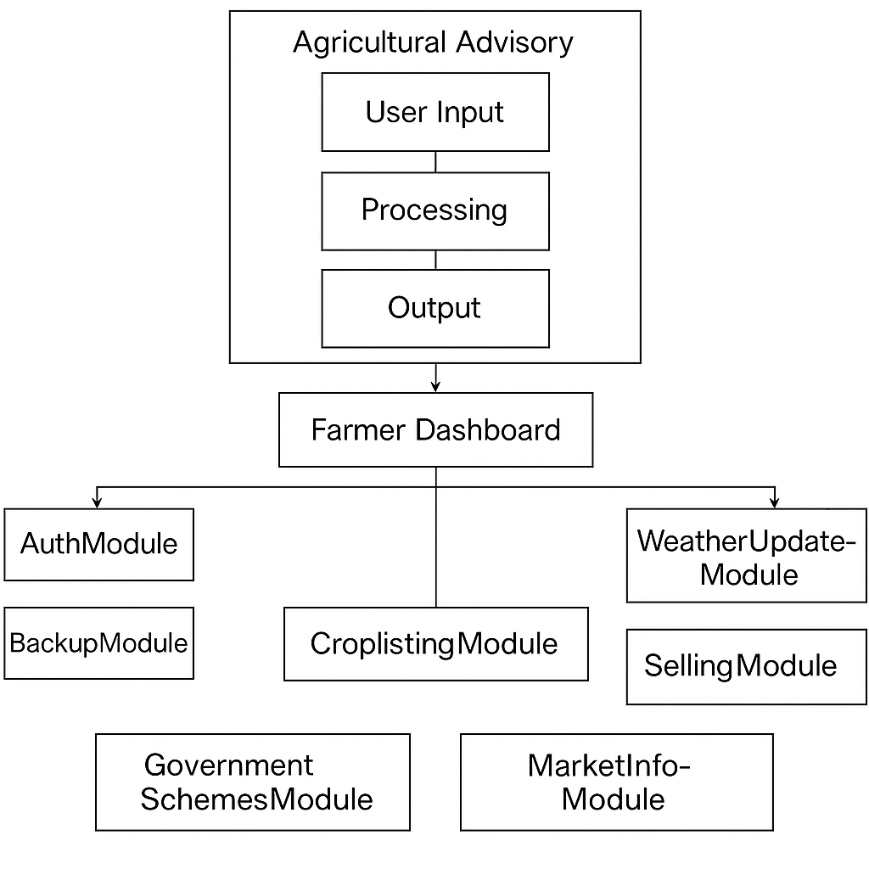

1. Profile of the Problem
Farmers in rural and semi-urban areas often lack timely access to critical agricultural data, including market prices, weather forecasts, government schemes, expert advice, and secure payment solutions. This information gap leads to poor decision-making and financial instability. The lack of an integrated digital platform exacerbates this issue.
2. Existing System (If any)
Currently, there are disjointed solutions such as mobile applications for weather, websites for market prices, and offline advisories from local officers. However, these systems are not integrated, user-friendly, or accessible to many farmers due to digital illiteracy and infrastructural limitations.
3. Introduction to Existing System
The existing systems primarily function independently. Apps such as “AgriApp” or “Kisan Suvidha” provide fragmented services. They do not provide a consolidated platform that integrates all critical agricultural services and support in one place.
4. Scope of Existing System
The existing system supports certain functions like:
- Providing crop prices
- Weather forecasting
- Announcing government schemes
However, they fail in providing personalized, real-time support, payment integration, expert consultations, or seamless user experience in local languages.
- Future Scope of the Existing System
- Integration with AI and ML for predictive analytics
- Multilingual voice-based support
- IoT-based crop monitoring
- Enhanced UI/UX for low-literacy users
6. Problem Analysis
- Lack of centralized access to diverse services
- No real-time expert consultation
- Manual processes in government services and subsidies
- Unsecured or no digital payment systems
- No personalized support based on crop/soil/weather

7. Product Definition of New System
The Farmer Support Platform is a Java-based digital solution designed to:
- Authenticate users and manage profiles
- Provide real-time market and weather updates
- Deliver personalized crop advisories
- Integrate government schemes and subsidies
- Enable expert consultations via chat/voice
- Manage digital payments
- Send notifications and alerts
- Store and back up data securely
8. Feasibility Study for New System
- Technical Feasibility: Java-based backend, MySQL for database, accessible on mobile and desktop
- Economic Feasibility: Cost-effective, government-funded potential
- Operational Feasibility: Easy-to-use interface, local language support
- Legal Feasibility: Complies with data protection norms and IT Act
9. Project Planning for New System
- Phase 1: Requirement Gathering
- Phase 2: System Design
- Phase 3: Module-wise Implementation
- Phase 4: Testing and Validation
- Phase 5: Deployment and Feedback
10. Software Requirement Analysis
- Frontend: JavaFX / Android Interface
- Backend: Java (Servlets, JSP)
- Database: MySQL
- API Integration: Weather, Market Prices
- Hardware: Smartphone/Desktop with internet
11. Introduction
The new system aims to bridge the digital divide by providing a one-stop platform tailored to the needs of farmers, focusing on ease of access, real-time data, and expert support.
12. General Description
The platform is modular and scalable, composed of multiple services including user management, data services, expert consultations, and financial tools. It supports both online and offline functionalities.

13. Specific Requirements
- Login/Signup module
- Market & Weather Data Fetch Module
- Expert Chat/Call Integration
- Scheme Eligibility Checker
- Notification Engine
- Transaction Management
- Detailed Design of New System
Each module will have its own Java class/services:
- Module 1: UserAuth.java
- Module 2: MarketInfoService.java
- Module 3: WeatherService.java
- Module 4: SchemeChecker.java
- Module 5: Main Module.java
- Module 6: PaymentGateway.java
- Module 7: Dashboard Module
- Module 8: Crop Management Module

Design, DFDs, Flowchart and ER-Diagram of each Module

- User Authentication and Profile Management Module
Functionality: Handles farmer registration, login, and authentication.
Features: User authentication via mobile number, email, or social media. Profile management (farmer details, location, farm type). Password management (reset, OTP-based authentication).

- Design of Module
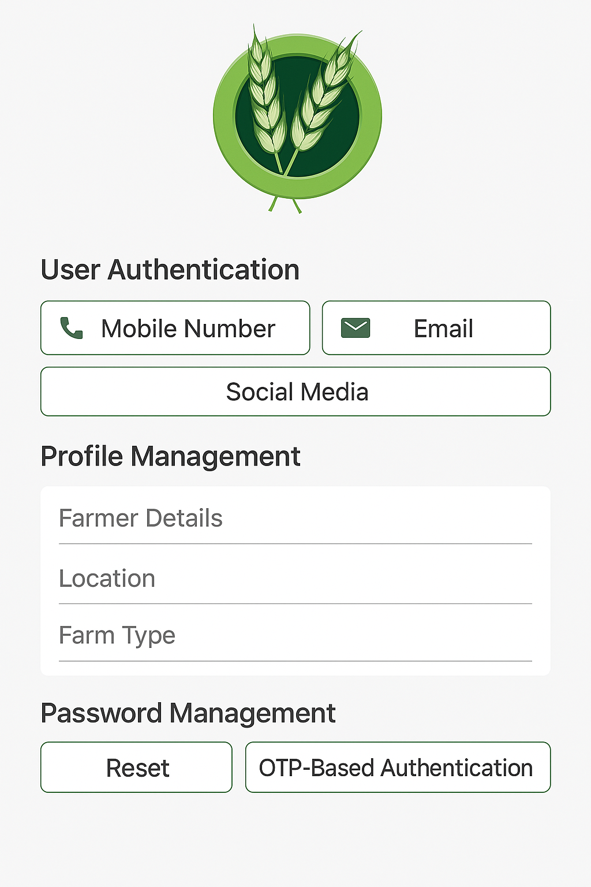

- DFDs

Level 0
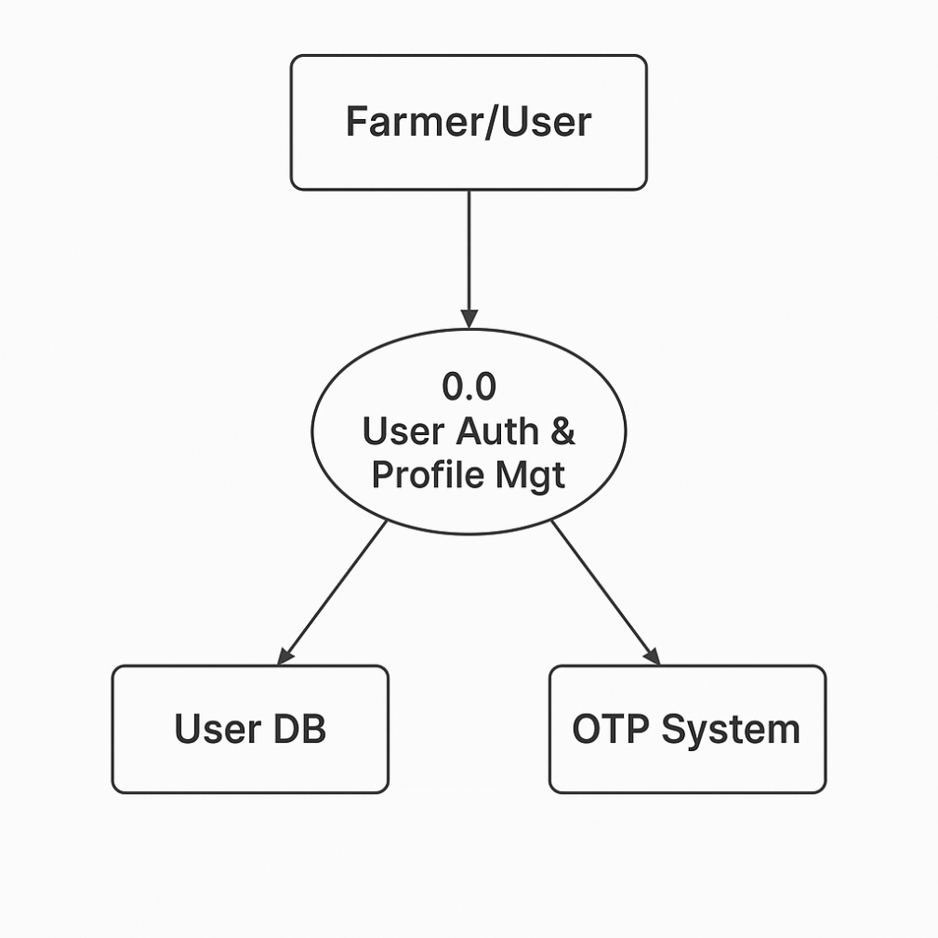

Level 1
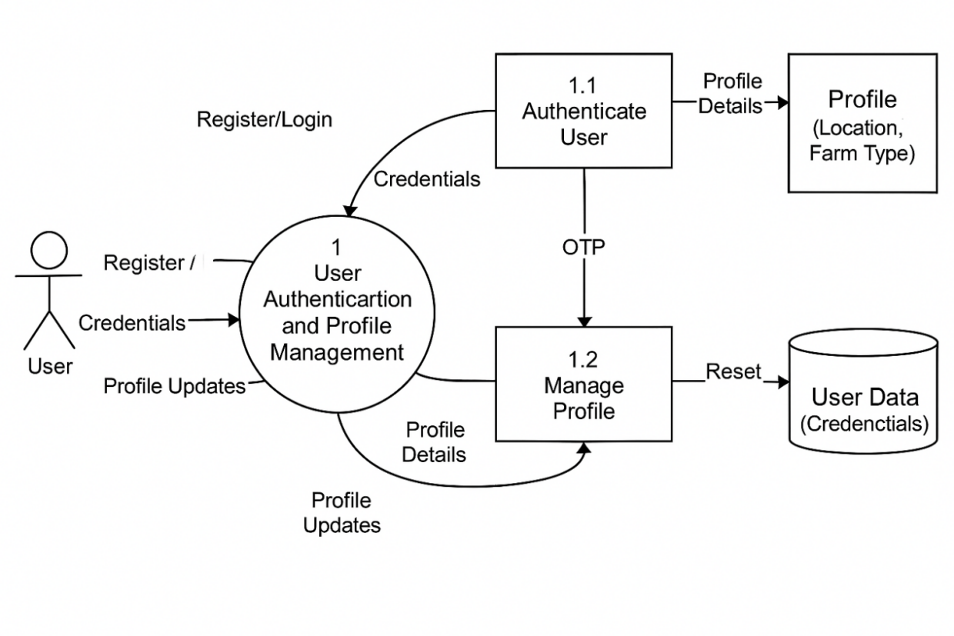

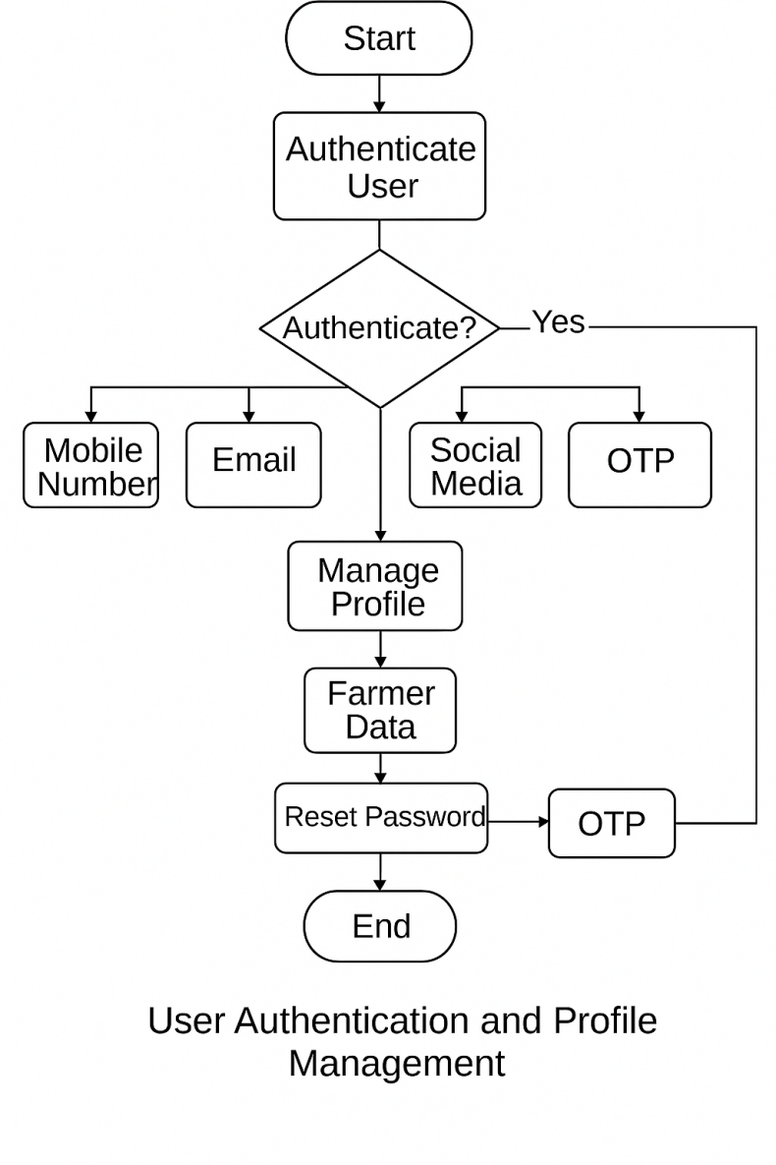
- Flowcharts

- ER-Diagram
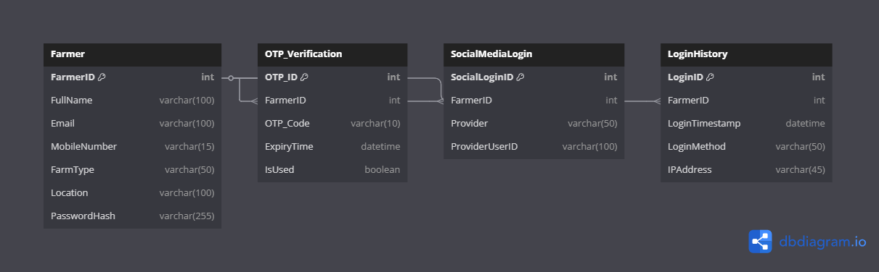

- Market Information Module
Functionality: Provides real-time market prices and trends.
Features: Live crop price updates from local and national markets. Demand forecasts and price trends.
Alerts for price drops or demand spikes.
Location-based market insights.

- DFDs

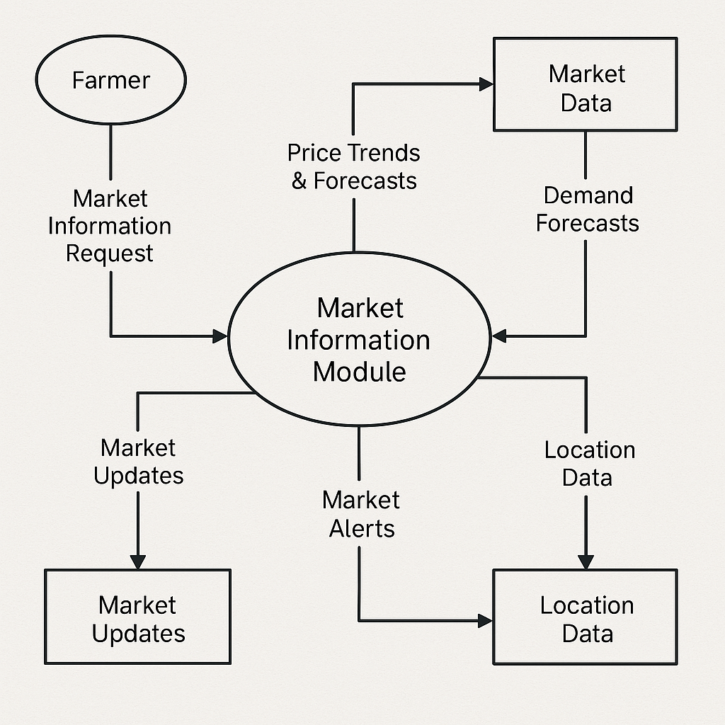

- Flowchart

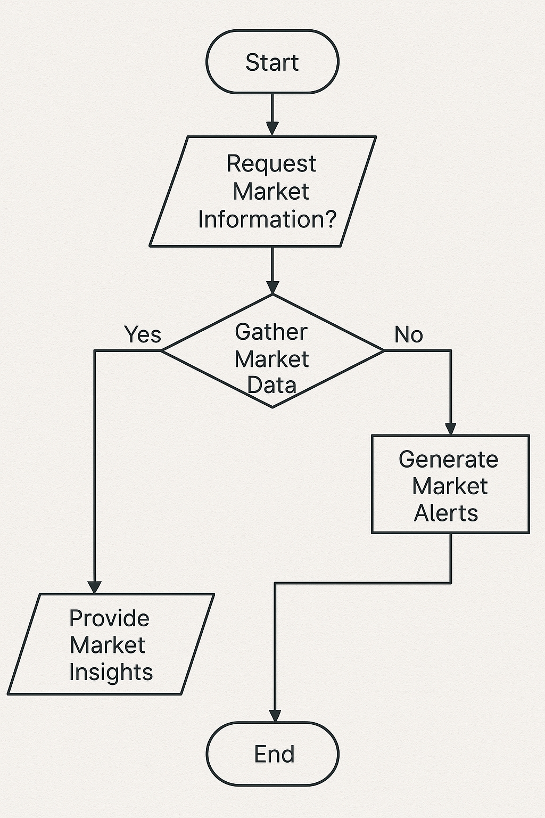

- ER-Diagram
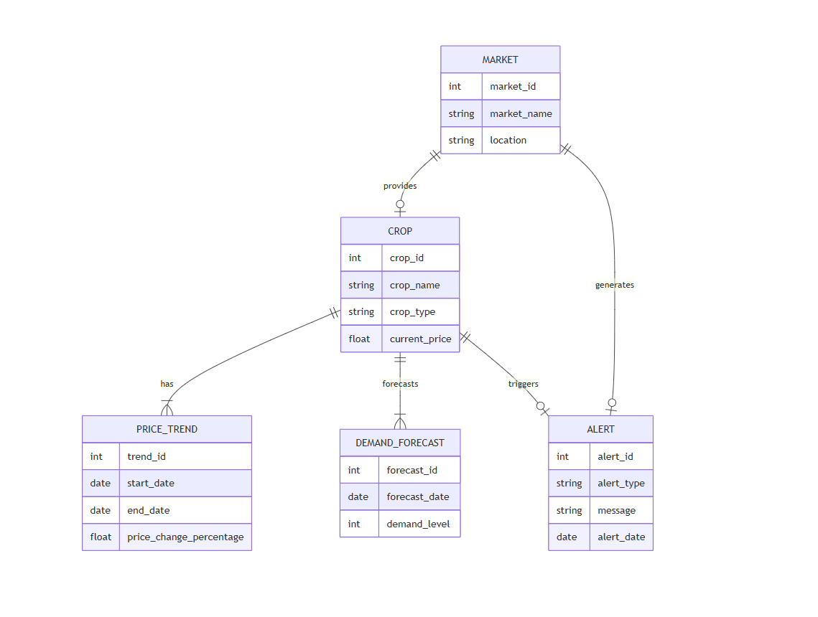

- Weather Updates Module
Functionality: Delivers weather forecasts to help farmers plan better.
Features: Daily, weekly, and monthly weather forecasts.
Alerts for extreme weather conditions.
Crop-specific weather advice.
Integration with weather APIs (e.g., OpenWeather, AccuWeather).

- DFDs

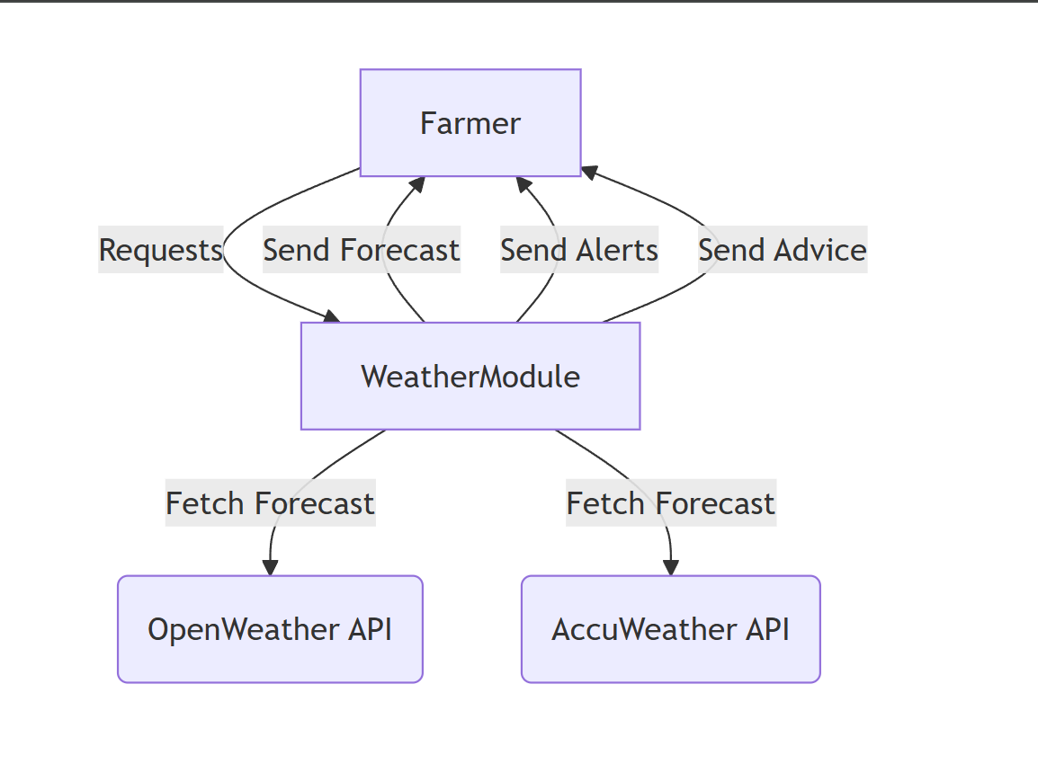

- Flowchart
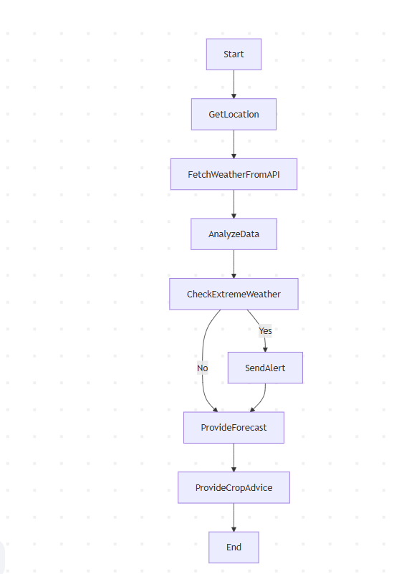

- ER-Diagram

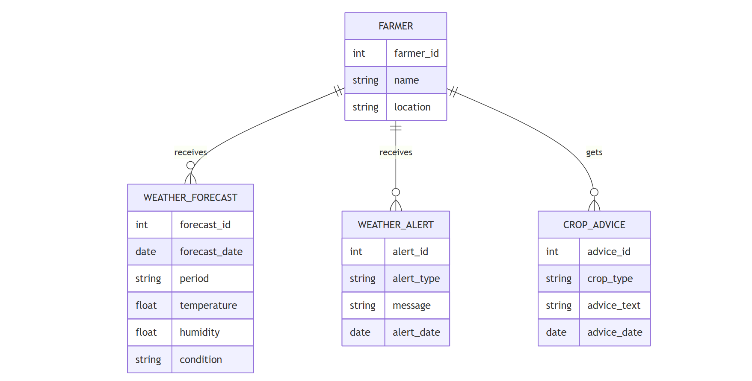

- Government Schemes and Subsidies Module
Functionality: Provides farmers with information about government grants, subsidies, and financial aid.
Features: List of active government schemes.
Eligibility criteria and application guidance.
Notifications for new schemes or deadlines.
Integration with government APIs for real-time data.

- DFDs

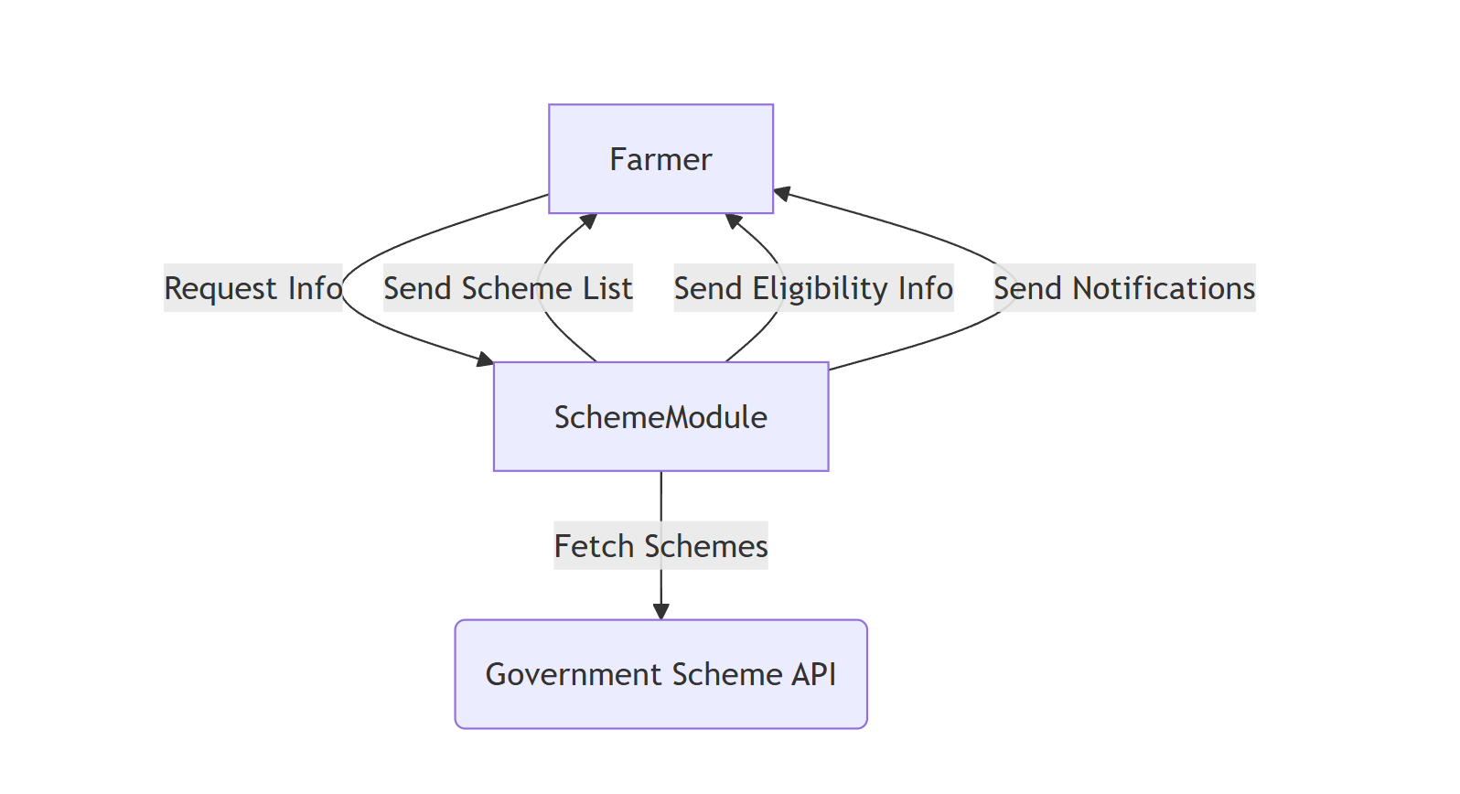

- Flowchart
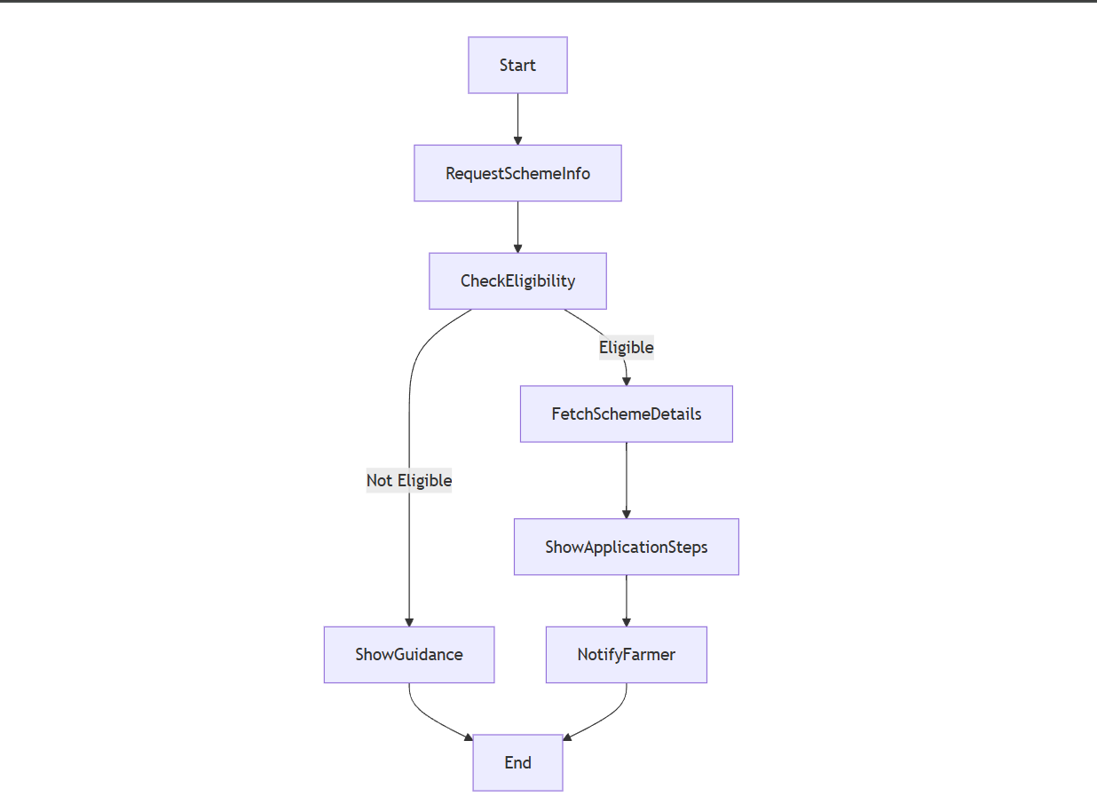

- ER-Diagram

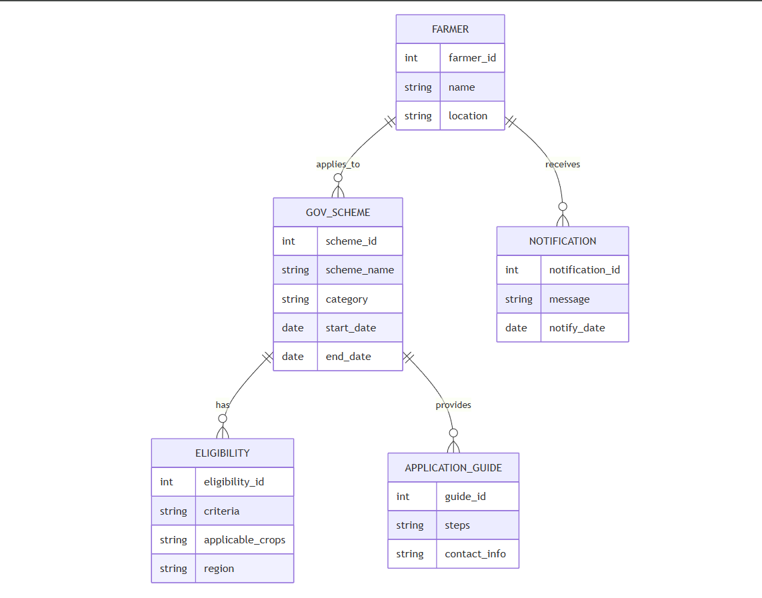

- Agricultural Advisory and Expert Consultations Module
Functionality: Connects farmers with experts and provides AI-based farming advice. Features: AI-driven chatbot for quick farming solutions.
Expert consultations via messaging, voice, or video calls.
Community forums for farmer-to-farmer discussions.

- DFDs
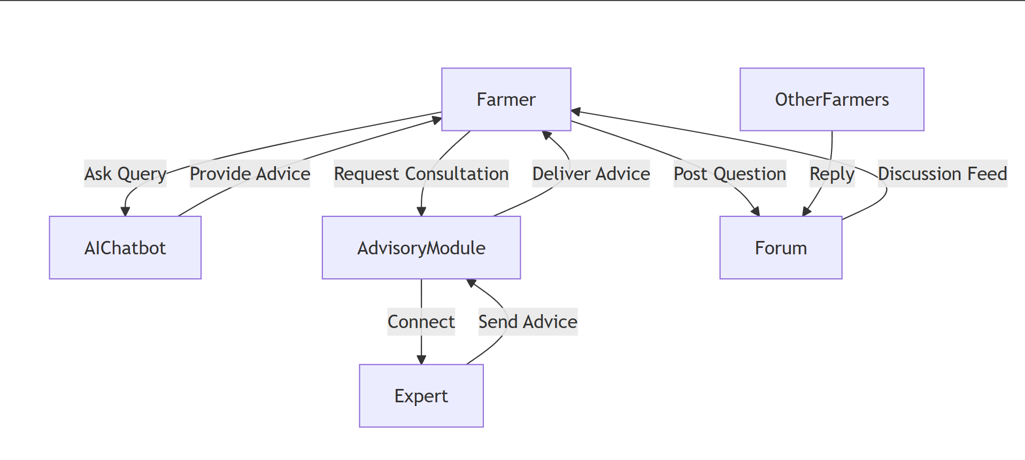

- Flowchart

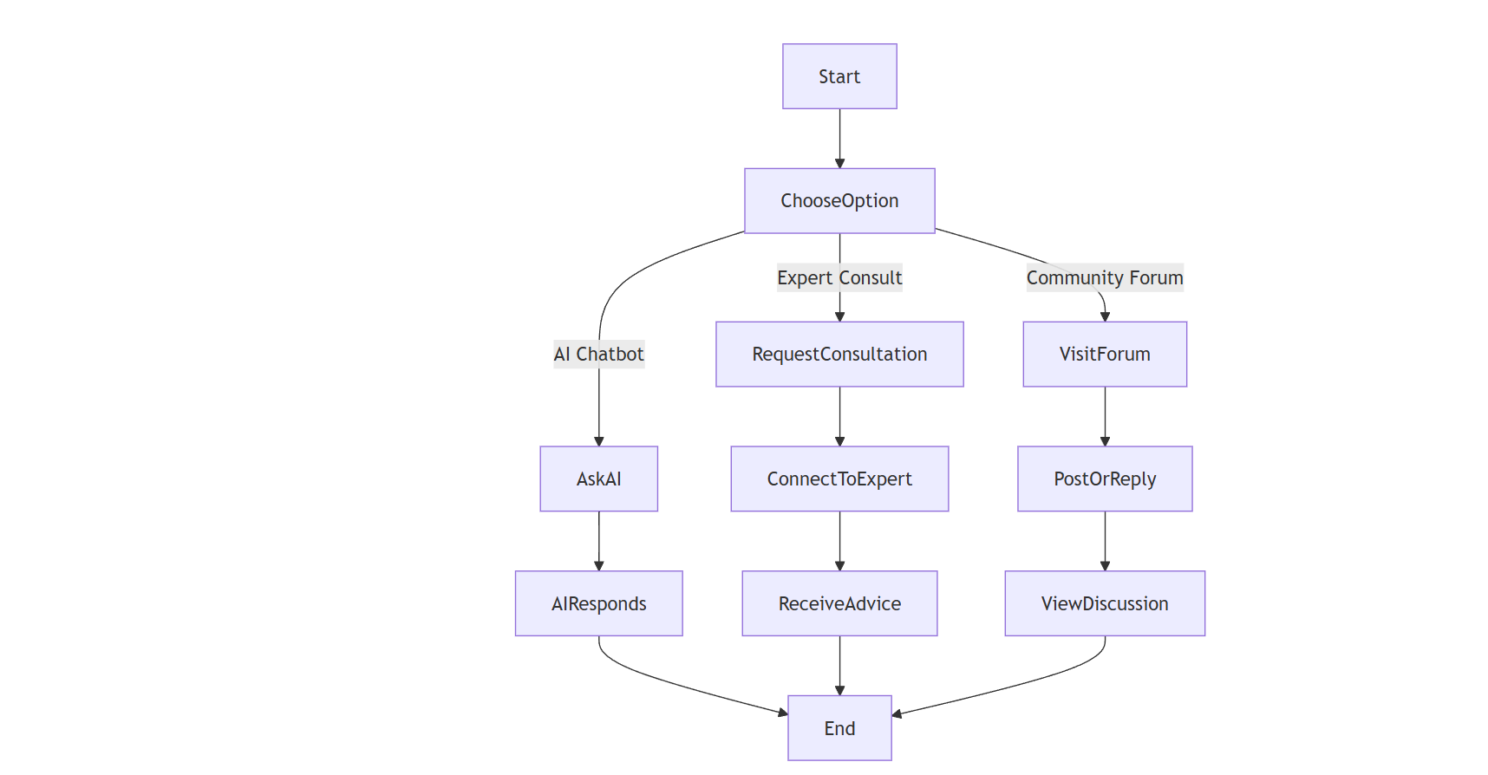

- ER-Diagram
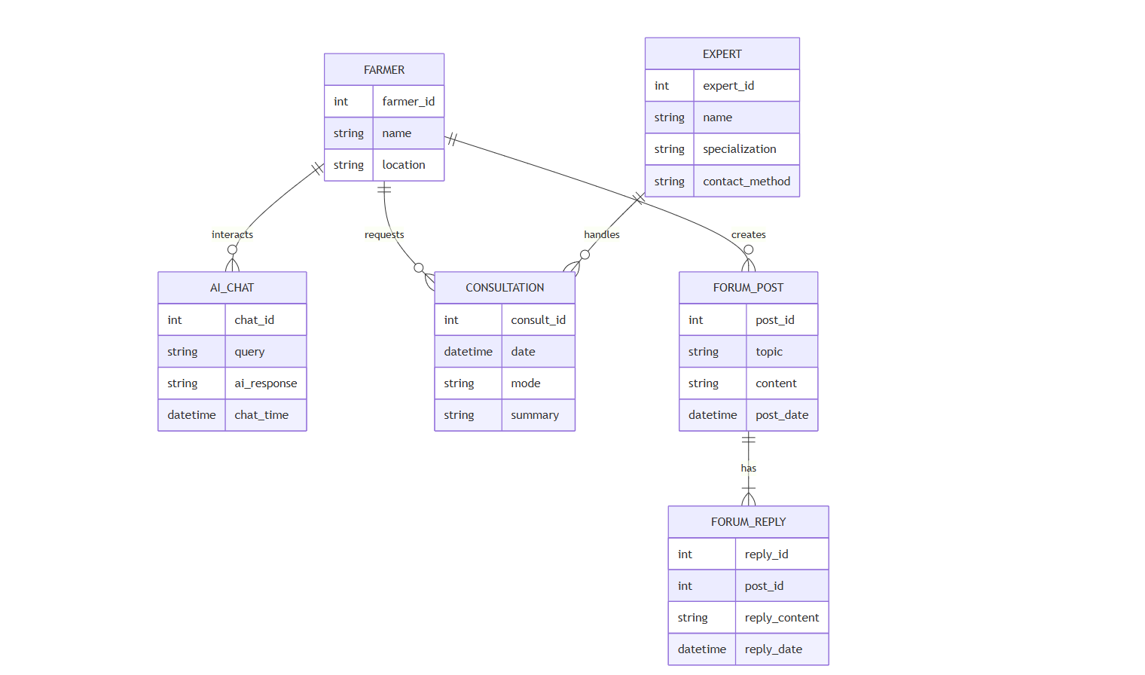

- Payment and Transaction Module
Functionality: Enables digital transactions for farm-related purchases or sales. Features:
Integration with UPI, bank transfers, and wallets.
Transaction history and invoice generation.
Secure payment processing for e-commerce transactions.

- DFDs
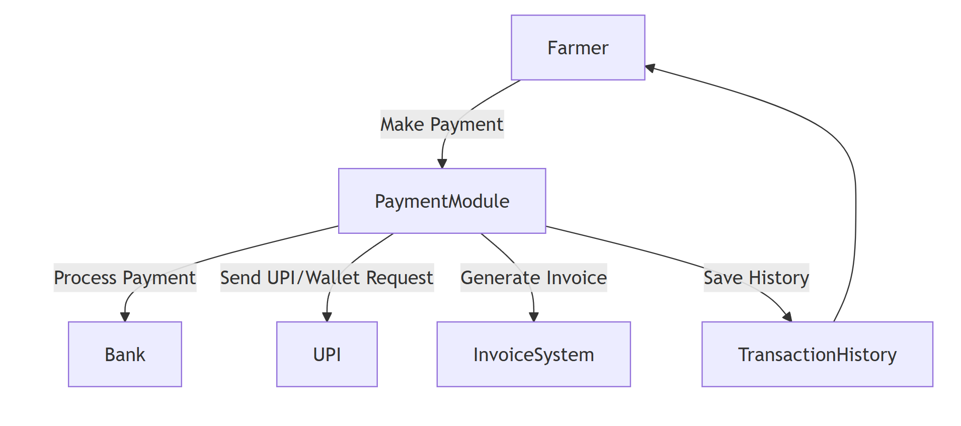

- Flowchart
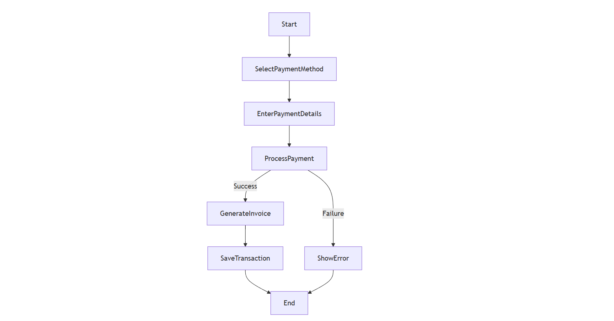

- ER-Diagram

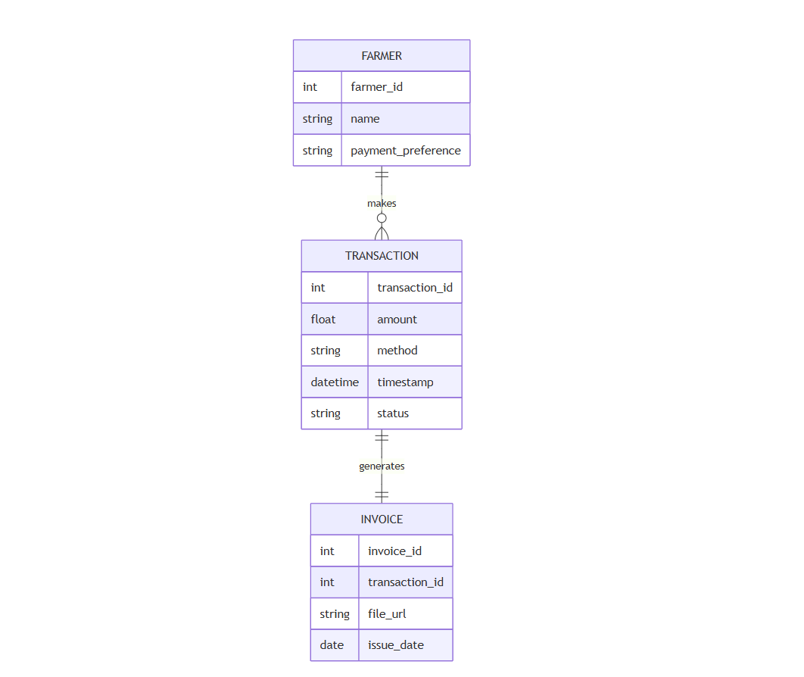

- Dashboard Module
Features:
• view and update profile details
• Navigation Buttons
• Market view
• MarketPrices
- CropManagement Module
Features:

• Crop Planning and Scheduling

• Soil and Land Management

